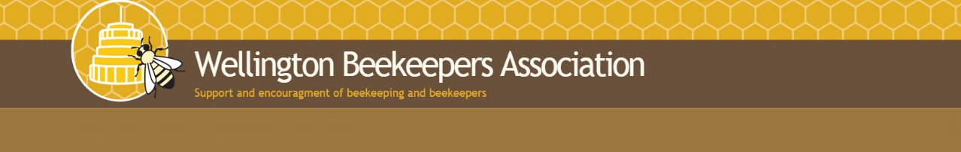

**Next meeting** | Wednesday 1st May 2024  
**Where** | Johnsonville Community Centre

**Editor**| Jane Harding [janeh@xtra.co.nz](mailto:janeh@xtra.co.nz)

Ededit

May 2024 Newsletter

Beginners session 6.45pm – Wintering Down – find out what you should be doing to get your bees and hives ready for winter.

Main Meeting: 7.30pm

Honey competition – judged by Frank Lindsay ONZM.  
“Whats Flowering Now” with Jane Harding and Tricia Laing. A powerpoint presentation on what our bees are feeding on at this time of year.

Contents

**2. President’s message**

**3. Honey Competition**

**5. Whats Happening Science-Wise – Male Discrimination**

**7. Warning – Don’t use honey in your bird feeder!**

**8. Digital Beekeeping App**

**8. Honey Buckets**

**9. Interesting article on varroa on bee larvae**

**10. Club services – extractor hire, tutin testing, varroa treatments**

**11.** What’s coming up?

11. Who can I talk to?

President’s Message

Honey and Covid-19

Last week a member of my household went down with COVID-19 for the fourth time. I have now had COVID-19 three times whereas my daughter and granddaughter have had it four times. Twice my granddaughter has brought it home from school. My daughter was getting depressed because it has been so debilitating for her. I decided to have a conversation with our GP to review how we try to avoid getting it; and, how we can care for ourselves better when we do get it - I wanted to avoid anti-viral drugs if possible.

One of the reasons that I became a beekeeper was because of my interest in the use of traditional healing practices of Pacific and Maori people.  On a number of occasions, in the past, I have received significant research grants from the Health Research Council of New Zealand to study the healing practices of Samoan and Maori people. Of course, historically Pacific and Maori people did not have access to honey or propolis but their pharmacopeia is plant based. I see the beehive as the ultimate factory for processing plants into concentrations of nutrients and ingredients beneficial to humans. I had heard rumours that research into honey and propolis could be used as a possible preventative for COVID-19.  My GP had followed up on the rumours he had heard, and was able to direct me to research into the use of honey and propolis not only as a preventative but also as a treatment for COVID-19.

Khandkar Shaharina Hossain, et al in *Heliyon*. 2020 Dec; 6(12): e05798. note that the National Institute of Health has started a clinical trial of natural honey for the treatment of COVID-19. They also note that there are “potential therapeutic effects of honey in fighting against COVID-19 by strengthening the immune system, autophagy, anti-inflammatory, antioxidative, antimicrobial, antidiabetic, anti-hypertensive as well as cardioprotective effects.” In addition the authors report that “without some minor issues, there is no report of the serious harmful effects of honey on the human body.” Another study showed that both honey and propolis had the potential to provide similar therapeutic effects.

The studies I found, all identified some effect of honey and/or propolis on COVID-19 but conservatively recommended additional research. None discussed dosage in any detail. In our household we had been using honey regularly as a spread on toast to help with our response to local pollen allergies.  Now we take a teaspoon of honey daily to boost our immune system in case we have to deal with yet another infection of COVID-19.

Honey Competition

This year’s honey competition will be held at the meeting this month (1 May). Please bring your honey samples to the meeting well before 7.30pm, soon after 7pm would be great so we can get them recorded and entered for judging.

Frank will be ably assisted by James Scott in the judging. The winner will be presented with the

The rules of the competition are on the website and repeated here:

The aim of this competition is to get members to prepare and present a sample of their own honey.

There are three classes in the competition:

* Liquid Honey.  This is the standard honey produced from extraction.  The emphasis is on quality of presentation, it is not about the taste of the honey.  Ensure that there are no air bubbles, particles, granulation, and suitably low water content.

A cup is awarded to the winner of the liquid honey class.

* Creamed Honey.  The emphasis is once again on presentation, with the aim being to have a smooth and consistent texture to the honey.
* Comb Honey.  Entries to be a frame of honey that would be suitable for cutting and packing as comb honey.  Emphasis is on the presentation of the frame.  Please bring a complete frame.

**Conditions of entry:**

* Entries in classes 1 and 2 are to be presented in a clear, glass jar (around 350ml) with a well-fitting lid.
* Entries in class 3 are to consist of a complete frame (either full, ¾ or ½ depth).
* No labels or markings on the jar or lid for entries in classes 1 and 2.   The frame in class 3 should also be clear of any identifying marks.
* There is a limit of one entry per member for each class.

**Tips and advice:**

* The secret in this competition is to take great care in filtering your honey to remove impurities and to get rid of air bubbles.
* The cleanliness and clarity of the container is also important.
* Start only with the best honey that has low moisture content (so that it will keep).
* Judges’ comments from previous years have indicated a high standard of entries, but there have been some recurring problems with impurities such as bee’s legs, air bubbles and high levels of moisture.  Pay particular attention to these things to come up with a winning standard of entry.  
  Prepare more than one entry and select the best for the competition.

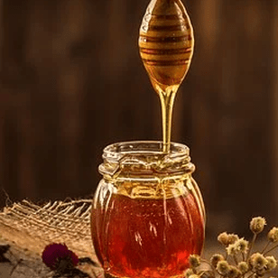

What’s Happening Science-Wise – with Phil Lester

**Discrimination against weak males! Low quality drone are evicted from hives.**

By Phil Lester

In many bird species, it is the males that are brightly coloured with fine feathers, or that have to sign beautiful songs in order to attract a female. The quality of the male song or plumage is an indicator of male health. The females are judging the males, mating only with the healthiest and best.

Do female bees similarly evaluate drone quality? Do they have a preference for nice smelling males that are large, strong and healthy? And what happens to the weaker or poor-quality males in a hive? These were the questions asked by Izaak Gilchrist and team from Purdue University in a paper published in April.

First, the authors injected drone with a lipopolysaccharide. The injection was to give the drone an immune challenge that caused the drones to be slightly sick. Indeed, the drone were seen to mount an immune response and lost body mass. They were smaller and weaker. The injected, sick drones were then placed back into a small hive.

From previous studies we know that sick worker bees are evicted from hives by their sisters. Sometimes sick workers will even altruistically self-evict. Would sick drones be similarly kicked out, or leave on their own accord?

Smaller, weaker and sick drones were preferentially evicted from the hives. The sick drones didn’t self-evict. instead, the worker bees forcibly removed the sick and weaker males from the hive. It seems clear that the female workers can and do evaluate drone quality.

Next, the authors examined how the bee smell. The scientists measured the drone smell by examining the cuticular hydrocarbons. And the sick bees did have a different smell. The sick individuals had a different hydrocarbon profile to healthy and strong drones. These different smells could potentially be used by workers to assess drone quality and health.

In other studies with worker bees, scientists have taken the hydrocarbons from sick workers and transferred them to healthy workers. The healthy workers that smelt sick were then evicted from the hive.

But when the authors of this study took the hydrocarbons from sick drones and put them on healthy drones, there was no increase in eviction.

The authors suggest that workers are indifferent to the smell or hydrocarbon profile of drones. Instead, they concluded that workers were just evicting low-quality drones based on mass. Smaller drones might be easier to bully and evict.

So, yes, female workers in a hive do evaluate their brothers and remove weaker males. Drones are a drain on the hive, contributing nothing and eating resources. It makes sense for the workers to do a little culling.

Reference

Gilchrist, I. R., et al. 2024. To house or oust: Honey bee (*Apis mellifera*) colonies can evaluate and evict drones of low quality. Behavioral Ecology and Sociobiology 78(4): 47. DOI: 10.1007/s00265-024-03461-8

Dead drones outside a hive - photo credit Honey Bee Suite


Dead drones outside a hive - photo credit - Honey Bee Suite

Don’t use Honey in your Bird Feeder!

The Treasurer has had to destroy four AFB-infected hives recently that were situated in the central city and both the Management Agency and experienced local beekeepers are mystified about the possible source. We believe it is very likely that a resident in the Thorndon area has been feeding birds with honey. Honey is a well-recognised source of AFB. To quote Mark Goodwin (Beekeeping scientist) “ Retail packages of honey have been tested in a number of countries and detectable levels of spores were found in 12 – 83% of samples tested. A survey of 32 retail lines of NZ honey found AFB spores in 25%.”

So the Club recommends all beekeepers advise their families and friends that if they want to feed nectar-loving birds such as tui, bellbirds, silver-eyes and kaka they should use a sugar solution NOT honey – either their own or any purchased from local shops.

And if you want to know the best ways to encourage native birds into your garden, Forest and Bird have a great guide to what to do: <https://www.forestandbird.org.nz/resources/feeding-native-birds-garden?gad_source=1&gclid=CjwKCAjw57exBhAsEiwAaIxaZrutNTMnROoNlcei518Wy8DtY638IYyYaiSos2ohlZO0nEyXX660IhoCoiMQAvD_BwE>

Their advice for sugar water is to make it very dilute (1 part sugar to 8 parts water) to avoid attracting bees and wasps. Better still, plant some native plants in your garden to get the birds to come and stay.

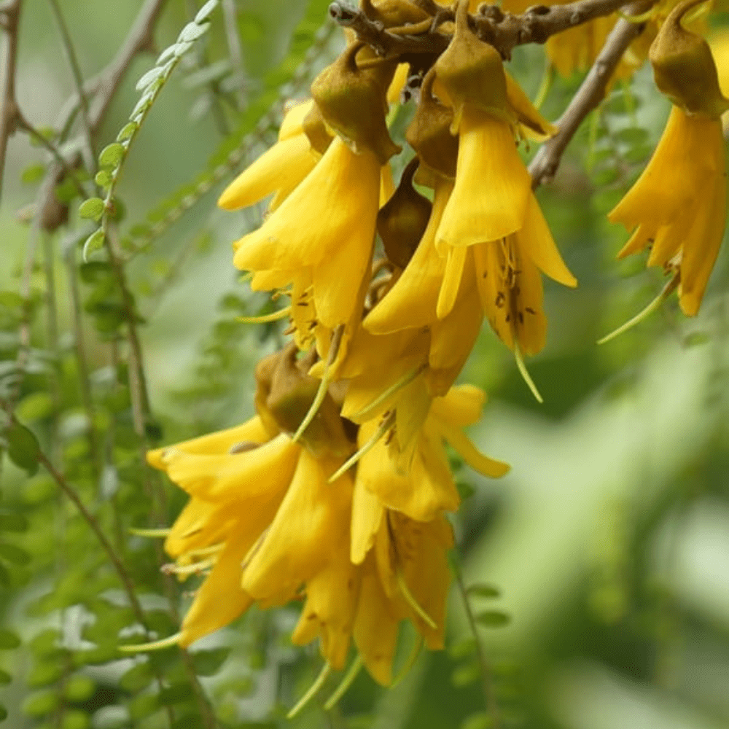 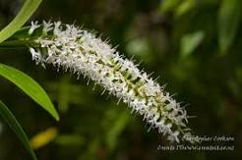 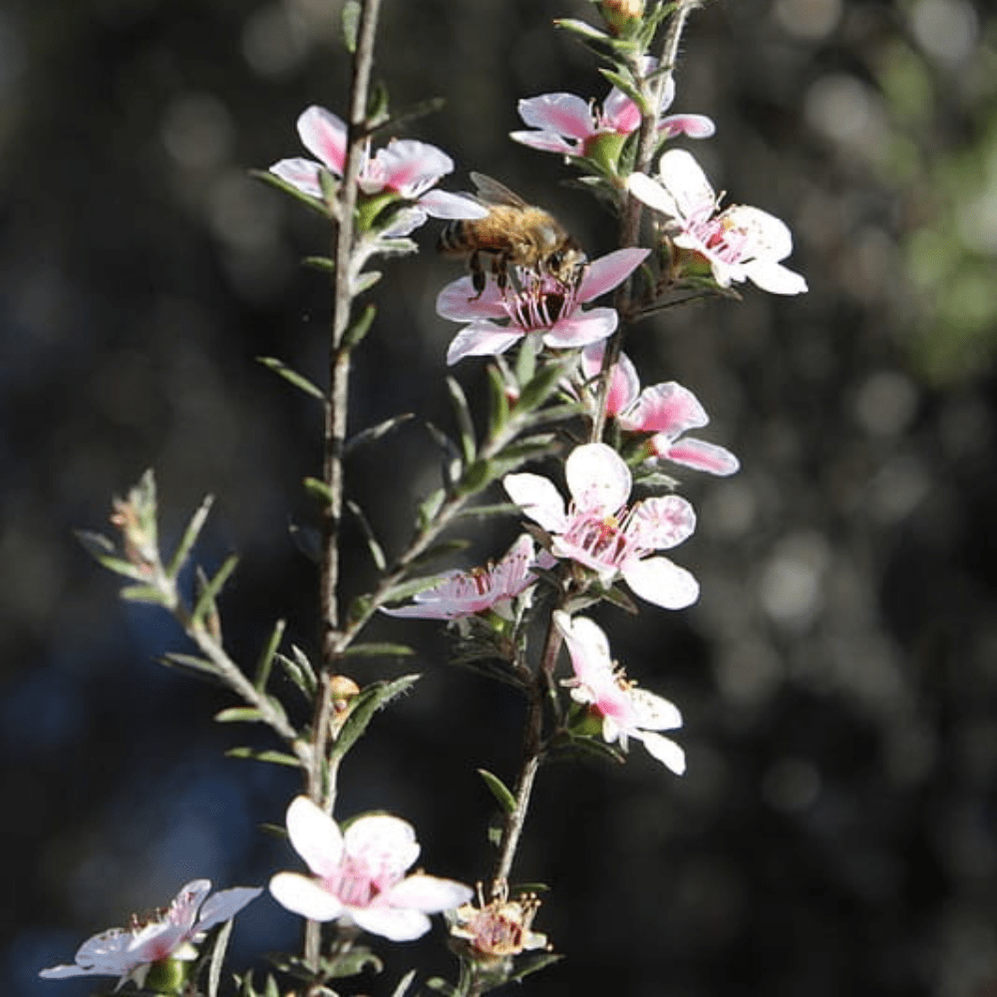

Digital Beekeeping App

The club has been approached by a Portuguese beekeeper who has developed a digital beekeeping app. The app is downloadable via the Google Playstore (Bee2go). Joao Jorge is keen to share the app with beekeepers around the world and increase the productivity and sustainability of beekeeping. His aim with the app is to simplify hive management, allowing beekeepers to focus on the health and productivity of their bees.

If you’re keen to try it, I’m sure Joao would love to know what you think.

NB. The WBA has not tried this app and we don’t have any comment on whether it works or will be useful (though we’d like to know to!)

You can get hold of Joao at [simpleapps2go@gmail.com](mailto:simpleapps2go@gmail.com)

Honey Buckets to give away

The club has been offered a number of buckets with lids for honey. The buckets are large orange Mitre 10 buckets which were previously used to transport honey to Wellington from the South Island. There are about 50 buckets to find a home for. If you think you could use a few, please contact Glenn Inwood at [g.i@ocls.co.nz](mailto:g.i@ocls.co.nz)

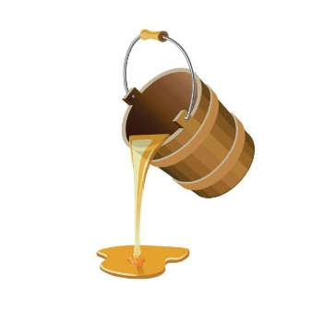

Varroa on Larvae feed differently than varroa on adult bees

Here’s an interesting article on the difference between how varroa mite feed on bee larvae as opposed to adult bees. All more information for our understanding the bees worst enemy.

<https://phys.org/news/2024-03-honeybees-worst-enemy.html#google_vignette>

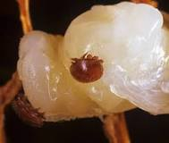

Varroa on bee larvae

Club Services

A reminder to all members that the club offers the following services to members as part of your membership:

Extractor Hire. The Club has two manual four-frame extractors for hire. Cost is $20 per hire and hire periods are usually Mon - Thurs or Fri – Sun. Hire includes a cappings bin and tool, and nylon capping strainer bags which allow you to spin the cappings themselves at the end of your extraction session. You will need to buy or borrow your own filter strainers and buckets. Full operating instructions are provided. Extractor bookings should be made to the Treasurer ([treasurer@beehive.org.nz](mailto:treasurer@beehive.org.nz)). Because each extractor stands over 1100mm in height and the legs splay about 700mm (width) to transport an extractor you will need a station wagon or hatch back with a wide opening door.

Varroa Treatments. Treasurer has a stock of Club-owned varroa treatment – currently Apivar ($50 for a 12 strip packet – four strips are required for the usual double brood box hive) or ApiLifeVar ($5 for a two dose wafer). Both these products will be available at the next meeting on Wed 3 April.

Tutin Testing. Treasurer is currently arranging tutin testing for $20 per sample. Free plastic screw top sample jars are available from the Treasurer for this purpose and samples are submitted to the lab in batches of ten for composite testing. If you are planning to sell or barter your honey tutin testing is a legal requirement. To date the club has this year submitted 30 samples from members and none have tested positive for tutin. **The final tutin test run for this season will be in May, get your samples into John at the May meeting.**

All enquiries for any of the above to the Treasurer – John Burnet Ph. 0274-379-062

What’s Ahead in 2024

June- Beginners – Equipment Session, including using polystyrene boxes  
Main meeting – Update on Varroa Research from Zoe Smeele and Tessa Pilkington

July- No beginners session  
Main meeting – AGM and Photo competition. Winter Social

Who can I speak to?

President - Patricia Laing [president@beehive.org.nz](mailto:president@beehive.org.nz)  
Treasurer – John Burnet (04) 232 7863 treasurer@beehive.org.nz Secretary – Jane Harding 027 421 2417 secretary@beehive.org.nz

Membership - James Scott - (04) 565 0164   
Web Master - Jason Bragg - (021 527 244)   
Librarian - Ellen Millar - (021 709 793)   
Supper co-ordinator - Barbara Parkinson – (04) 2379624   
Swarm WhatsApp Administrator - Jim Hepburn ( 021 926823)   
PK Tan - 021 109 3388   
Graeme Chisnall - 021-246-8662   
Janine Davie   
Millie Baker   
Newsletter Editor - Jane Harding - 027 421 2417